

Smart Campus Assistant
Web application for “Elad” campus
Version:
Written By Amit Cohen
08/03/2026

Revision history
Date | Version | Description | Author
08/03/2026 | 0.1v | Original | Amit Cohen
08/03/2026 | 0.2v | Modified Use Cases | Amit Cohen
09/03/2026 | 0.3v | Databases added | Amit Cohen
09/03/2026 | 0.4v | Added:  -Traceability table  -Updated FR  -added section 2.3. | Amit Cohen
09/03/2026 | 0.5v | Added:  -link table for student and course  -Updated non-functionality requirements | Amit Cohen

1. Introduction
1.1. Purpose
This Software Requirements Specification (SRS) describes the functional and non-functional requirements for the Smart Campus Assistant web application for the “Elad” campus.
The purpose of this document is to provide a clear description of the system behavior, constraints, and expected functionality.
This document will be used by:
- developers implementing the system
- project supervisors and instructors
- stakeholders responsible for validating the system’s behavior
All requirements described in this document correspond to version 1.0 of the Smart Campus Assistant system.

1.2. Project Scope
The Smart Campus Assistant is a web-based platform designed to assist students in accessing campus information quickly and efficiently and navigate the site's broad platform and its services.
The system allows students to submit questions related to campus services such as:
- course information
- administrative procedures
- campus facilities
- schedules and announcements
The system processes the request and generates a response using an AI service integrated into the platform.
The main objectives of the system are:
- improve student access to campus information
- reduce administrative workload
- provide fast automated responses
- create a centralized digital assistant for campus services
- developed to improve a better and more meaningful visitor experience and improve communication with visitors.

2. Overall Description
2.1. Description
The Smart Campus Assistant system is a web-based application designed to support students in accessing campus-related information and services. The system will function as a centralized digital assistant for the campus community.
The application allows students to submit questions through a web interface. These questions are processed by an integrated AI service which generates responses based on campus information and knowledge sources.

2.2. Stakeholder
Stakeholder | Role | Interest
Student | Primary user of the system | Interact with the AI system to obtain campus information.
Campus Administration | Provide official information | Provide official campus information and reduce administrative workload.
Teacher/Lecturer | Provide professional information | Provide academic or professional information through the system database.
AI Engineering Service | External service that generates answers | Ensure the AI service produces accurate responses.
IT department and security | Infrastructure management | Ensure security and system availability

2.3. System Architecture and AI Service Responsibility
The Smart Campus Assistant system separates responsibilities between the system backend and the external AI service to ensure security and proper data access control.
The system backend is responsible for all security-sensitive operations, including user authentication, authorization, validation of user requests, and database access. The backend retrieves relevant campus information from the database and determines what information can be shared with the AI service. The backend is the only component that has direct access to the system database. The AI service does not have direct access to the database. Instead, the backend sends the AI service a filtered prompt that may include the user’s question and limited contextual information retrieved from the database. The AI service processes the natural language input and generates a response based on the provided context. After the AI service generates a response, the answer is returned to the backend. The backend stores the interaction in the system database and sends the final response to the user interface. This architecture ensures that sensitive information remains protected and that database access is controlled exclusively by the backend system.

3. Business Rules
3.1. Rules List
Rule ID | Rule Definition | Type
BR1 | Users must be authenticated before accessing the Smart Campus Assistant system. | Constraint
BR2 | Only administrators or IT staff are allowed to modify system configuration and information. | Authorization
BR3 | User accounts are created and managed by the university administration prior to system use. Self-registration is not supported. | Constraint

4. Traceability
4.1 Traceability Table
The Traceability Table connects business rules, functional requirements, and use cases. It allows stakeholders to verify that all business objectives are covered by system functionality.
Business Rule | Functional Requirement | Use Case | Description
BR1. Users must be authenticated | FR16. enforce role-based permissions | UC05 Login | Ensures only authenticated users can access the system
BR1. Users must be authenticated | FR1, FR2, FR8 | UC01 Ask Question | Only logged-in students can submit questions
BR1. Users must be authenticated | FR3, FR4, FR5 | UC02 View Chat History | Students can access their previous interactions
BR2. Only admins/lecturers can modify system info | FR9 - FR15 | UC03 Update Campus Information | Only authorized staff can modify course information
BR3. Accounts created by administration | FR1, FR15, FR16 | UC05 Login | Only pre-created accounts can access the system.

5. Functional Requirements
5.1. Student Users
FR1. The system must display a menu of available campus services to the students.
Acceptance Criteria:
- The menu must include at least three campus services: Ask Question, View Chat History, and View Timetable.
FR2. The system must allow students to select an option from the menu.
Acceptance Criteria:
- Each menu option must be clickable.
- Selecting an option must navigate the user to the corresponding route.
FR3. The system must validate the student's selection before processing the request.
Acceptance Criteria:
- The system must verify that the selected option exists in the menu.
- If the selection is invalid, the system must display an error message.

FR4. The system must process the selected option and retrieve the relevant campus information from the system database.
Acceptance Criteria:
- When the student picks option, it retrieves information from the system database
FR5. The system must display the requested information to the student through the Smart Campus Assistant interface.
Acceptance Criteria:
- The system must display the requested information in the user interface after retrieving it from the database.

FR6. The system may allow students to submit an additional question related to the selected service.
Acceptance Criteria:
- The interface must include a text input field for submitting questions.
- If user send second question its must pass through stages FR1 – FR 5 again.

FR7. The system must send the students’ requests to the AI service when additional explanation or assistance is required.
Acceptance Criteria:
- The backend must validate the question before sending it to the AI service.
- The backend must send the request to the AI service through a secure API call.
- The AI service must not have direct access to the system database.

FR8. The system must store the response generated by the AI service to the student.
Acceptance Criteria:
- The system must display the AI-generated response in the chat interface.
- The system must store the question and response in the Questions database table.
- The response and storing must be associated with the correct student id.

5.2. Professor/Lecturer
FR9. The system must allow authorized administrators or lecturers to update course information stored in the database.
Acceptance Criteria:
- Only users with the role of lecturer can access the course update interface.
- Unauthorized users must receive a 403 Forbidden response if they attempt to access the update functionality.

FR10. The system must allow authorized users to update course schedule details such as lecture hours and classroom location.
Acceptance Criteria:
- The system must validate that required fields are not empty before saving the changes.
FR11. The system must allow authorized users to update course descriptive information such as the course name or additional course notes.
Acceptance Criteria:
- Authorized users must be able to modify course name and course description fields.
FR12. The system must prevent administrators and lecturers from modifying protected student data.
Acceptance Criteria:
- The system must restrict modification of protected fields such as student ID.
- Any attempt to modify protected data must be rejected by the backend.
FR13. The system must prevent administrators and lecturers from deleting existing courses from the database.
Acceptance Criteria:
- The system must disable or block any delete operation on course records.
FR14. The system must store all approved updates to course information in the system database.
Acceptance Criteria:
- The system must save validated updates on the Course table.
- The updated information must be visible when the course information is retrieved again.

5.3. Security
FR15. The system must restrict modification privileges to authorized users only.
Acceptance Criteria:
- Students must not have permission to modify course information.
- Unauthorized attempts must return a 403 Forbidden response.
FR16. The system must enforce role-based permissions to ensure that students and lecturers can only access functions permitted to their role.
Acceptance Criteria:
- Students must only be able to access student-related functions such as asking questions and viewing chat history.
- Lecturers must be able to access course update functions.
- The system must verify the user's role before allowing access to restricted actions.

6. Use-Cases
6.1. Ask Question
UC01. Ask Question
Actor: Student
Goal: Receive an answer from the AI assistant
Precondition: The student is on the Smart Campus Assistant homepage.

Main Flow:
Step 1. The student enters a question in the input field.
Step 2. The system sends the question to the AI service.
Step 3. The AI service processes the question and retrieves relevant information from the database if needed.
Step 4. The AI service generates a response.
Step 5. The system displays the answer to the student.

Edge Case A: Empty Question.
If the student submits an empty question, the system displays a message asking the student to enter a valid question.

Edge Case B: Answer Not Found
If the AI service cannot find relevant information in the database, the system informs the student that the question cannot be answered.

Edge Case C: Unauthorized Prompt
If the student attempts to submit a restricted or unauthorized prompt, the system displays an error message and rejects the request.

Edge Case D: AI Service Unavailable
If the AI service is unavailable, the system displays a warning message and asks the student to try again later.

Postcondition
The student receives an answer or a system message explaining why the question could not be processed.

6.2. View Chat History
UC02. View Chat History
Actors: Student
Goal: Allow the student to view previous conversations with the Smart Campus Assistant.
Precondition: The student has previously interacted with the Smart Campus Assistant and is on the system webpage.

Main Flow:
Step 1. The student submits a question and receives a response from the AI service.
Step 2. The system stores the questions and responses in the student’s chat history database.
Step 3. The student opens the chat history section.
Step 4. The system retrieves the stored conversations.
Step 5. The system displays chat history to the student.

Edge Case A: No Chat History
If the student has no previous interactions stored, the system displays a message indicating that no chat history is available.

Edge Case B: Offline Mode
If the system is in offline mode, the system retrieves and displays previously stored chat history without requiring a connection to the AI service.

Postcondition
The student can view previous conversations with the Smart Campus Assistant.

6.3. Update Campus Information
UC03. Update Campus Information
Actor: Lecturer / Authorized Staff
Goal: Allow authorized staff to update permitted course information stored in the system database.
Precondition: The lecturer account exists in the system, and the lecturer is logged in.

Main Flow:
Step 1. The lecturer logs into the system using their credentials.
Step 2. The system verifies the lecturer’s authorization and permissions.
Step 3. The lecturer accesses the course information management interface.
Step 4. The lecturer selects a course they are authorized to modify.
Step 5. The lecturer updates permitted course fields such as lecture hours, classroom location, course name, or additional course notes.
Step 6. The system validates the submitted data.
Step 7. The system updates the course information in the campus database.

Edge Case A: Unauthorized Access
If a user without lecturer privileges attempts to access the management interface, the system returns a 403 Forbidden response and denies access.

Edge Case B: Database Connection Error
If the system cannot connect to the database, the system displays an error message and the operation is cancelled.

Edge Case C: Data Conflict
If the inserted data conflicts with existing records in the database, the system displays a validation error.

Edge Case D: Missing Required Fields
If required fields are empty or invalid, the system rejects the submission and asks the lecturer to correct the input.

Edge Case E: Restricted Operation
If the lecturer attempts to modify protected data (such as student IDs, course identifiers, or deleting courses), the system rejects the request and displays an error message.

Postcondition
The admin receives an error message or approve if the task was done

6.4. View Timetable
UC04. View Timetable
Actor: Student
Goal: Allow the student to view their class timetable.
Precondition: The student is logged into the system.

Main Flow:
Step 1. The student opens the timetable section of the system.
Step 2. The system retrieves the student’s timetable from the campus database.
Step 3. The system displays the timetable including course names, locations, and times.

Edge Case A: No timetable available
If no timetable is available for the student, the system displays a message indicating that the timetable cannot be found.

Postcondition
The student can view their class schedule.

6.5. Login
UC05. Login
Actor: Student / Lecturer
Goal: Allow a registered user to access the Smart Campus Assistant system.
Precondition: The user's account exists in the system database.

Main Flow:
Step 1. The user navigates to the login page.
Step 2. The user enters their username and email.
Step 3. The system validates the credentials.
Step 4. The system verifies that the account exists in the database.
Step 5. The system creates a user session and grants access to the system interface.

Edge Case A: The user enters incorrect credentials.
The system displays an error message indicating invalid login details.

Edge Case B: The system cannot find the account in the database.
The system denies access and displays a message indicating that the account does not exist.

Postcondition
The user is authenticated and can access the system features according to their role permissions.

7. Use Case Diagram
The diagram below shows all the main actions a user can take in the Smart Campus Assistant, and which external systems are involved

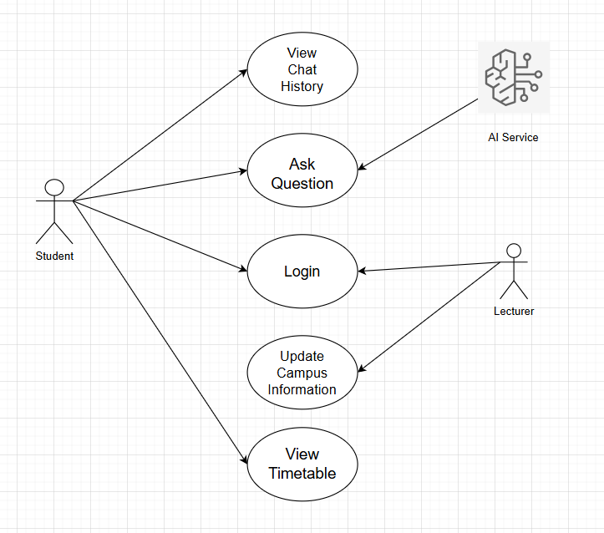

8. Sequence Diagram 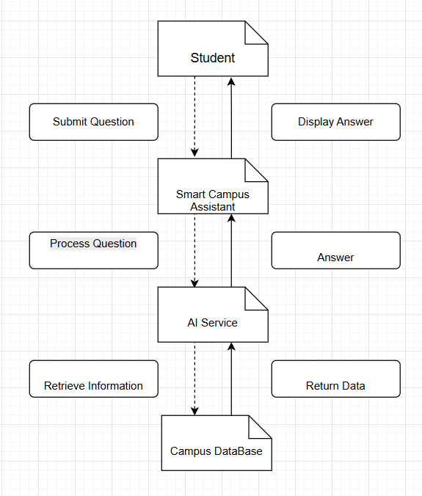

9. Non-Functional Requirments
Category | Requirement | Measurable Standard
Performance | Response time | The system must display answers to student questions within 5 seconds under normal network conditions.
Performance | Login processing | User authentication must be completed within 3 seconds after submitting credentials.
Security | Authentication | Only users with valid accounts stored in the system database may access the system.
Security | Data protection | Student identification numbers and protected data must not be modifiable by lecturers.
Security | Session control | The system must require a valid session token for accessing protected resources.
Usability | Interface clarity | The system interface must allow users to submit questions and view responses with no more than two interactions.
Usability | Error messages | The system must provide clear error messages when invalid input or unauthorized access occurs.
Compatibility | Browser support | The system must operate correctly on modern web browsers such as Chrome, Firefox, and Edge.
Scalability | Concurrent users | The system must support at least 100 simultaneous users without significant performance degradation.
Operations | Logging | The system must record important system events such as users login, options submissions, and system errors in a log file.
Operations | Monitoring | The system must monitor system indicators such as database connectivity, AI service availability, and system response time.
Reliability | System availability | The system must maintain at least 99% availability during normal operation.

10. Data Bases
10.1. Student Table:
Attribute | Description | Required | Type | Comment
student_id | Unique identifier for each student in the system | yes | Int (primary key) | Generated by system automatically
Username | The username used by the student to log into the system | Yes | VARCHAR (50) | Unique
Email | Student's email address used for identification | Yes | VARCHAR (100) | Unique
role | Defines the type of user in the system | Yes | VARCHAR (30) | Default will be: “student”
ID | Personal identification of the student | yes | TEXT | Cannot be modified.

10.2. Course Table:
Attribute | Description | Required | Type | Comment
course_id | Unique identifier for each course in the system | Yes | Int (Primary Key) | Automatically generated by the system
course_name | Name of the course | Yes | VARCHAR (100) | Course title displayed to students
lecture_hours | Scheduled lecture hours for the course | Yes | VARCHAR (50) | Example: Monday 10:00-12:00
classroom | Classroom or location where the course is held | Yes | VARCHAR (50) | Example:  Room 201
lecturer_id | Identifier of the lecturer responsible for the course | Yes | Integer (Foreign Key) | References Lecturer table
course_description | Additional information about the course | No | TEXT | Optional course details or notes

10.3. Lecturer Table
Attribute | Description | Required | Type | Comment
lecturer_id | Unique identifier for each lecturer in the system | Yes | Int (Primary Key) | Automatically generated by the system
username | Username used by the lecturer to log into the system | Yes | VARCHAR (50) | Must be unique
email | Lecturer email address used for identification | Yes | VARCHAR (100) | Must be unique
department | Department the lecturer belongs to | No | VARCHAR (100) | Example: Computer Science
role | Defines the user role in the system | Yes | VARCHAR (20) | Default value: "lecturer"

10.4. Questions Table
Attribute | Description | Required | Type | Comment
question_id | Unique identifier for each question in the system | Yes | Int (Primary Key) | Automatically generated by the system
student_id | Identifier of the student who asked the question | Yes | Integer (Foreign Key) | References Student table
question_text | The question submitted by the student | Yes | TEXT | The content of the question
answer_text | The response generated by the AI assistant | Yes | TEXT | The system's answer to the question
timestamp | Date and time when the question was submitted | Yes | DATETIME | Used for question history ordering

10.5. Student-Course Table
Attribute | Description | Required | Type | Comment
student_course_id | Unique identifier for each enrollment record | Yes | Int (Primary Key) | Generated by the system Automatically
student_id | Identifier of the student enrolled in the course | Yes | Int (Foreign Key) | References to Student table
course_id | Identifier of the course the student attends | Yes | Int (Foreign Key) | References to Course table

